**Exponential Moving Average – EMA**

An exponential moving average (EMA) is a type of [moving average](https://www.investopedia.com/terms/m/movingaverage.asp) that is similar to a simple moving average, except that more weight is given to the latest data. It's also known as the exponentially [weighted](https://www.investopedia.com/terms/w/weighted.asp) moving average. This type of moving average reacts faster to recent [price changes](https://www.investopedia.com/terms/p/price-change.asp) than a [simple moving average](https://www.investopedia.com/terms/s/sma.asp).

## **Interpreting the EMA**

Like all moving average indicators, they are much better suited for [trending markets](https://www.investopedia.com/terms/t/trending-market.asp). When the market is in a strong and sustained [uptrend](https://www.investopedia.com/terms/u/uptrend.asp), the EMA indicator line will also show an uptrend and vice-versa for a down trend. A vigilant [trader](https://www.investopedia.com/terms/t/trader.asp) will not only pay attention to the direction of the EMA line but also the relation of the [rate of change](https://www.investopedia.com/terms/r/rateofchange.asp) from one bar to the next. For example, as the price action of a strong uptrend begins to flatten and reverse, the EMA’s rate of change from one bar to the next will begin to diminish until such time that the indicator line flattens and the rate of change is zero.

Because of the lagging effect, by this point, or even a few bars before, the price action should have already reversed. It therefore follows that observing a consistent diminishing in the rate of change of the EMA could itself be used as an indicator that could further counter the dilemma caused by the lagging effect of moving averages.

## **BREAKING DOWN 'Exponential Moving Average - EMA'**

The 12- and 26-day EMAs are the most popular short-term averages, and they are used to create indicators like the [moving average convergence divergence (MACD)](https://www.investopedia.com/terms/m/macd.asp) and the [percentage price oscillator (PPO).](https://www.investopedia.com/terms/p/ppo.asp) In general, the 50- and 200-day EMAs are used as signals of long-term trends.

Traders who employ [technical analysis](https://www.investopedia.com/terms/t/technicalanalysis.asp) find moving averages very useful and insightful when applied correctly but create havoc when used improperly or are misinterpreted. All the moving averages commonly used in technical analysis are, by their very nature, [lagging indicators](https://www.investopedia.com/terms/l/laggingindicator.asp). Consequently, the conclusions drawn from applying a moving average to a particular market chart should be to confirm a market move or to indicate its strength. Very often, by the time a moving average indicator line has made a change to reflect a significant move in the market, the optimal point of market entry has already passed. An EMA does serve to alleviate this dilemma to some extent. Because the EMA calculation places more weight on the latest data, it “hugs” the price action a bit tighter and therefore reacts quicker. This is desirable when an EMA is used to derive a trading entry signal.

##### **Formula**

EMA = ( P - EMAp ) * K + EMAp

Where:

* P = Price for the current period
* EMAp = the Exponential moving Average for the previous period
* K = the smoothing constant, equal to 2 / (n + 1)
* n = the number of periods in a simple moving average roughly approximated by the EMA
* 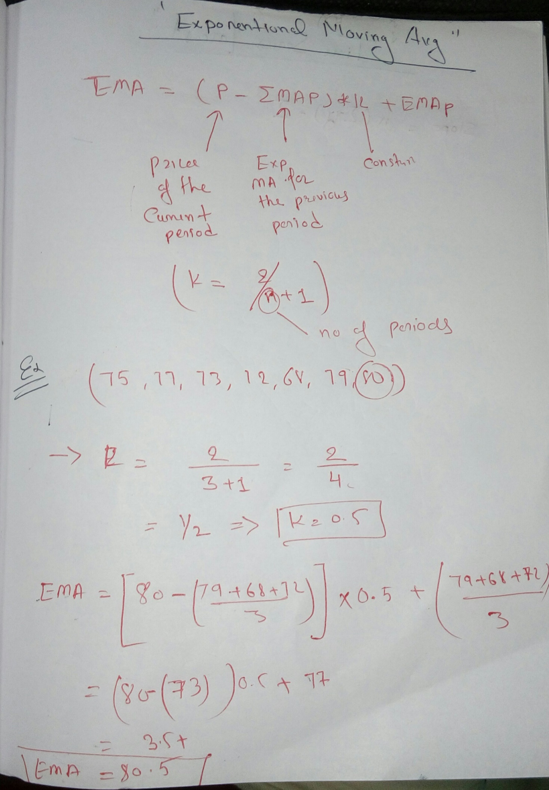

## **Common Uses of the EMA**

EMAs are commonly used in conjunction with other indicators to confirm significant market moves and to gauge their validity. For traders who trade [intraday](https://www.investopedia.com/terms/i/intraday.asp) and fast-moving markets, the EMA is more applicable. Quite often traders use EMAs to determine a trading bias. For example, if an EMA on a [daily chart](https://www.investopedia.com/terms/d/dailychart.asp) shows a strong upward trend, an intraday trader’s strategy may be to trade only from the long side on an intraday chart.



**Python code:**

import numpy as np

import pandas as pd

import matplotlib.pyplot as plt

df = pd.read_csv('G:/internship/datasets/TATASTEEL.NS.csv')

df = df.iloc[:,3]

def ExpMovingAverage(values, window):

weights = np.exp(np.linspace(-1., 0., window))

weights /= weights.sum()

a = np.convolve(values, weights, mode='full')[:len(values)]

a[:window] = a[window]

return a

print(ExpMovingAverage(df,3))

#df.plot(y=['Close'], figsize = (5,2.5))

df.plot(y=['ExpMovingAverage'], figsize = (5,2.5))

**Graph:**

